POSTMAN EVIDENCE - CHECKOUT FLOW
Waktu Eksekusi: 2026-07-14 10:17:31
--------------------------------------------------
[1] REQUEST: Inquiry Checkout Page
URL: https://tst.yokke.co.id:7778/gateway/IPGAPI/v1/inquiries
Status Code: 200
Request Body : {
"amount":1029,
"currency":"IDR",
"customer":{
"name":"john doe",
"email":"john.doe@test.com",
"phoneNumber":"08123456789",
"country":"Indonesia",
"postalCode":"12345",
"locality":"Jakarta",
"address":"Jl. Bahagia no. 1"
},
"order":{
"id":"LandingPage-17839990521632913",
"items":[{
"name":"Pertalite - Subsidi",
"quantity":1,
"amount":1029,
"url":"www.test.com",
"type":"BBM",
"id":"BBM-Subsidi"
}
],
"tokenOption":"off"
},
"referenceUrl":"https://demoshop.yokke.xyz"
}
Response Body:
{"id":"5ccd2017-837d-4e94-9688-d2698ed5cf1b","createdTime":"2026-07-14T03:17:32.320Z","referenceId":"MILandingPage-17839990521632913","expirationTime":"2026-07-14T04:17:32.320Z","status":"unpaid","amount":1029,"currency":"IDR","paymentSources":["cybersource","mtiiso","bniapiva","cimb","gopay","indodana","kredivo","ovo","mandiriapiva","bridirectdebit","bricard","btniso","ocbciso","mtiqris"],"urls":{"selections":"https://tst.yokke.co.id:2443/checkout/csDKi5aT2txcxQ2t3qhP5p","checkout":"https://tst.yokke.co.id:2443/checkout/csDKi5aT2txcxQ2t3qhP5p"}}
--------------------------------------------------
[2] EXTRACTED GLOBAL VARIABLES:
Reference ID: MILandingPage-17839990521632913
Landing Page: https://tst.yokke.co.id:2443/checkout/csDKi5aT2txcxQ2t3qhP5p
Input Data Kartu
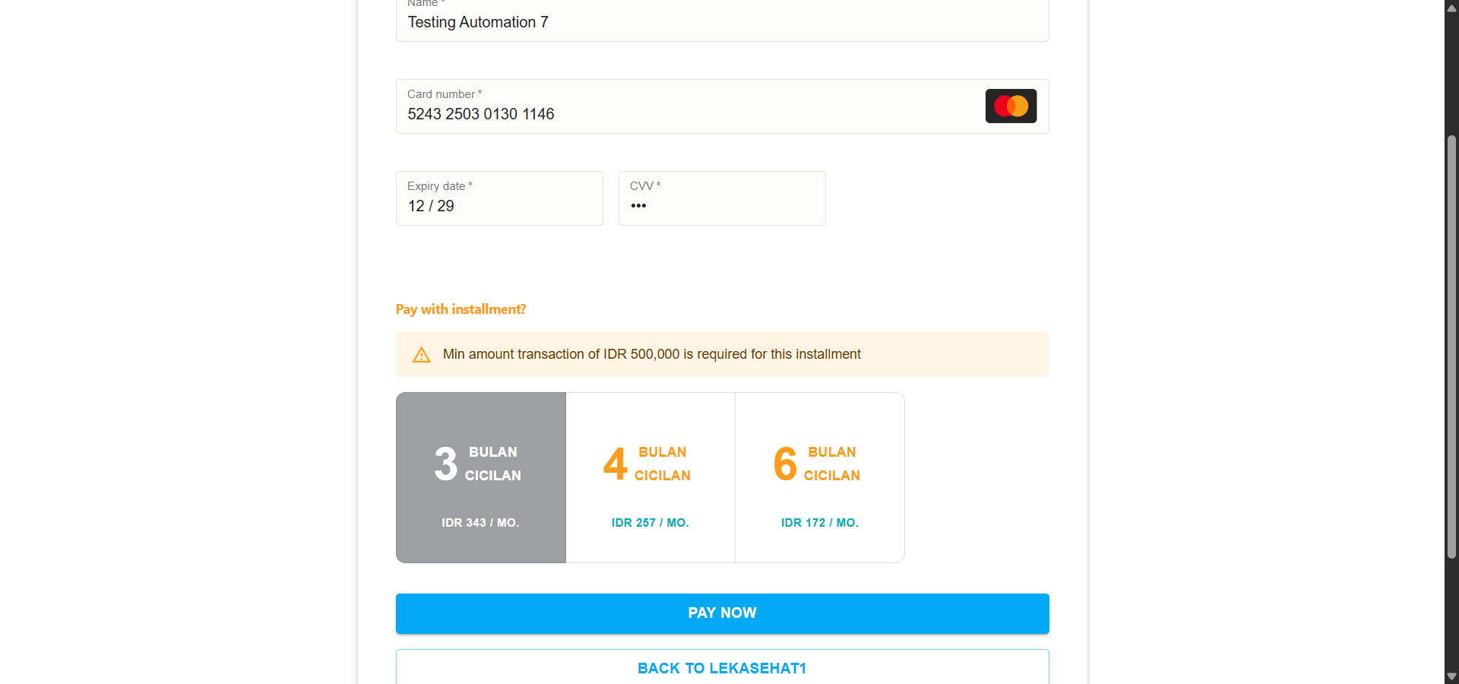
Hasil Payment
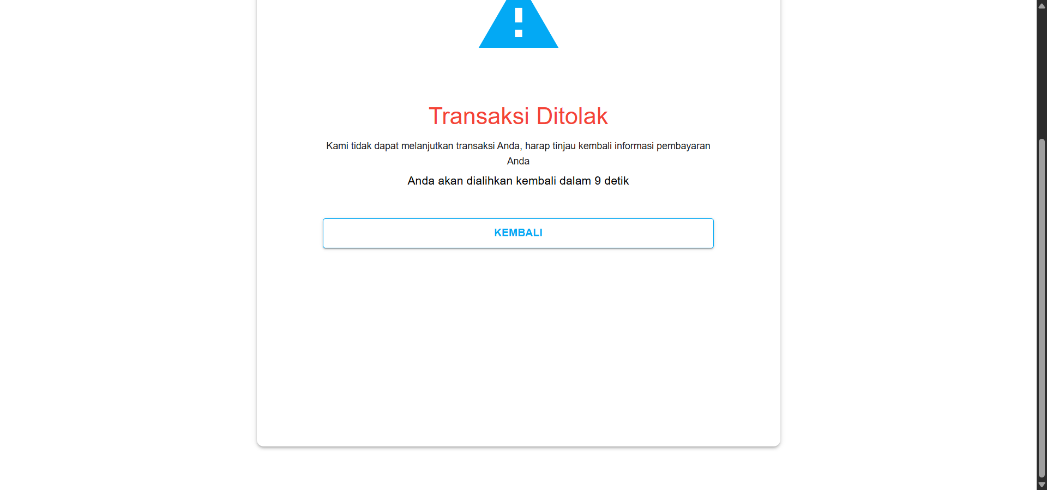
Admin
Maas
FEP

